**PROJECT INCREMENT 2**

**PROJECT TITLE**: REAL TIME POLL SYSTEM

**PROJECT TEAM MEMBERS**:

|  |  |
| --- | --- |
| **Name** | **Class ID** |
| RAJASHEKAR REDDY VEMULA | 25 |
| KOUSHIK REDDY SAMA | 21 |
| SAI KRISHNA REDDY KATTA | 14 |

**What is the use of real time polling system and how is it benefited to the public?**

A real time electronic polling system allows users cast their votes with ease without the trouble and stress of visiting a kiosk. This makes it easily accessible because it will be utilized by users anywhere within the world. Adding real time functionality to the appliance improves the user experience as votes are seen in real time.

**How a real time polling system is different from a voting system?**

In the traditional voting system, a user has to choose a person to vote and have to press button on the electronic voting machine (EVM) which is beside the person’s name. Whereas in the real time poll system a user can vote to their favorite person by opening a web application and enter the email id for verification purpose. After the email id is verified a user can vote for their favorite player by clicking on his image and can wait to see the results in the form of a pie chart. The purpose of email id is to stop the duplication of votes by a user.

**GOALS AND OBJECTIVES OF THE PROJECT:**

The main idea of this project is to build a real time poll system, where the users can vote to their favorite cricket players through a web application and users can also see the number of votes each player received.

The goal of our project is building a real time polling application using Angular, Pusher Service, MongoDB, and charts.js for data visualization. Using our application users will get to vote for their favorite cricket player in the Indian Premier League.

We’ll send our votes to the server and with the help of Pusher Service and update our polls in real time.

We’ll be using these tools to build our application:

* Express
* Node
* MongoDB
* Angular
* Charts
* Pusher Service

**Express**: Express.js, or just Express, may be a web application framework for Node.js, released as free and open-source software under the MIT License. it's designed for building web applications and APIs. it's been called the factual standard server framework for Node.js.

**Charts**: This tool is used for graphical representation of information and data which is called as Data Visualization.

**MongoDB**: MongoDB is a cross-platform document-oriented database program.

**Pusher Service**: Pusher is a hosted service that adds real-time data and functionality to web and mobile applications. Pusher sits as a real-time layer between your servers and your clients.

**Features**

1. Email ID to remove the duplicate votes.
2. Selecting or voting for a favorite Player.
3. Displaying the Statistics of Each Player.
4. User can see how other users have voted for their favorite players with display of vote count in a pie chart.

**Screenshots of Project Work**

app.component.html file

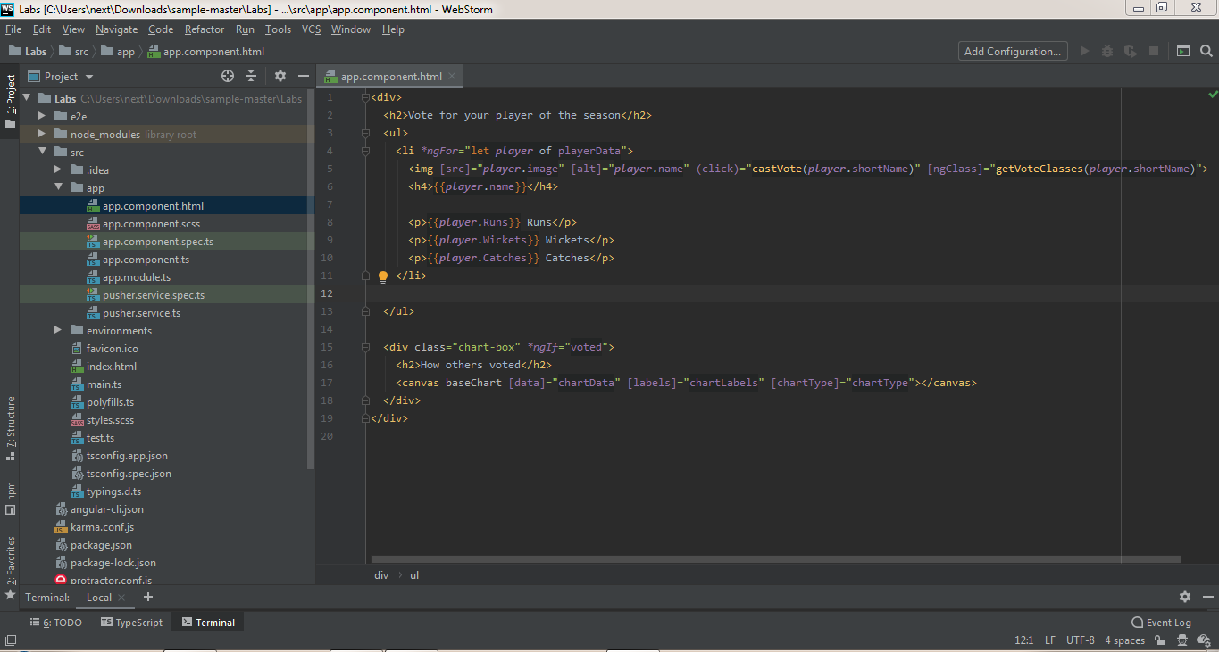

app.component.scss file

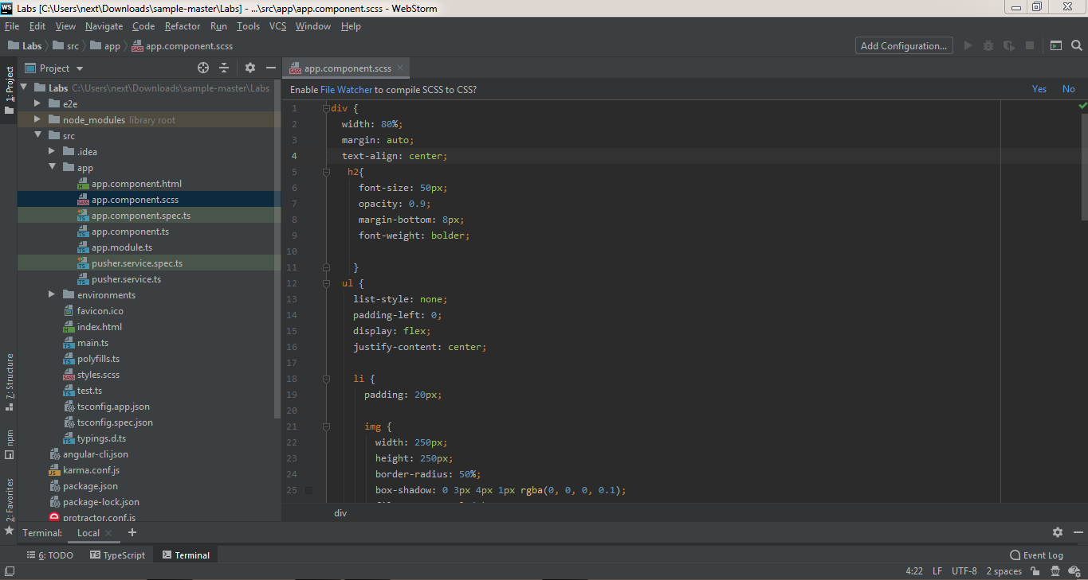

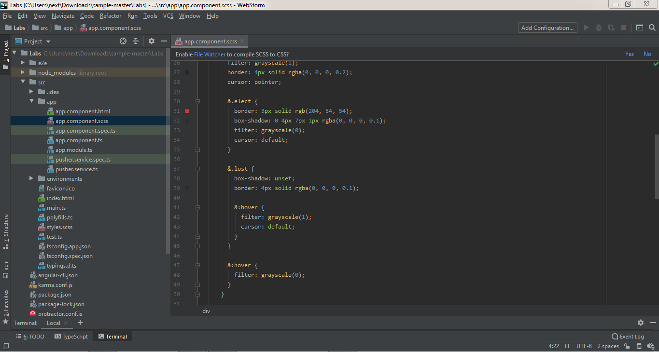

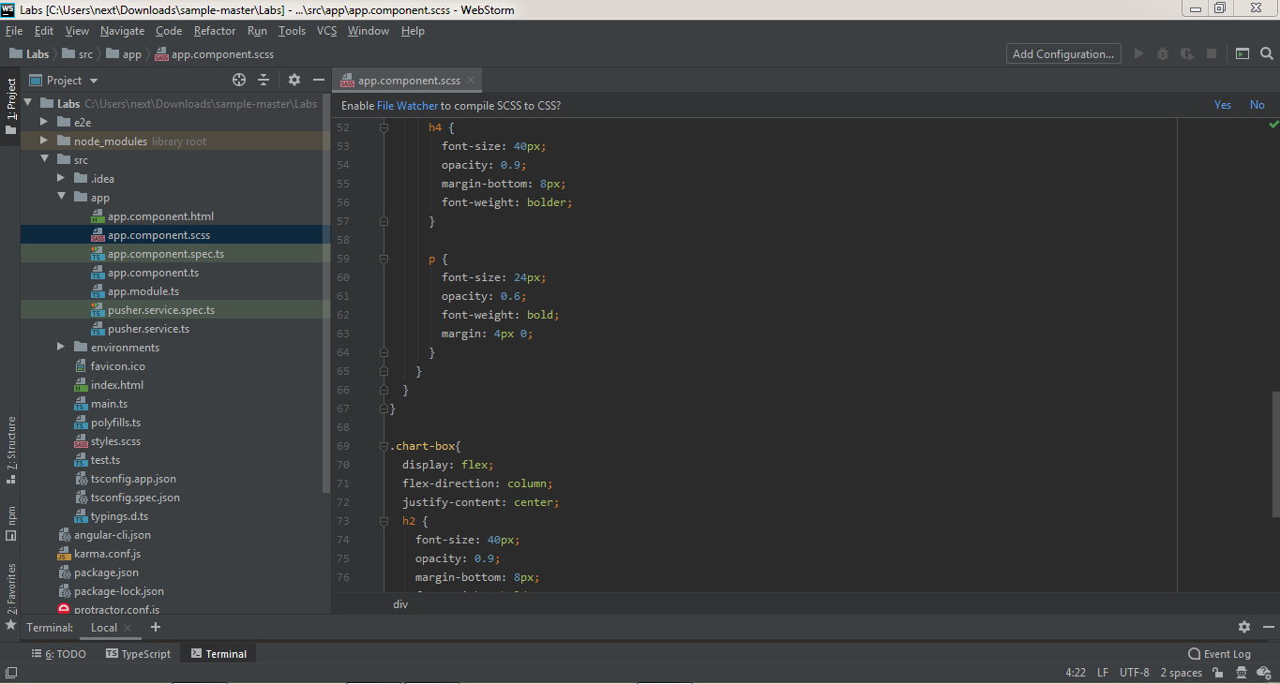

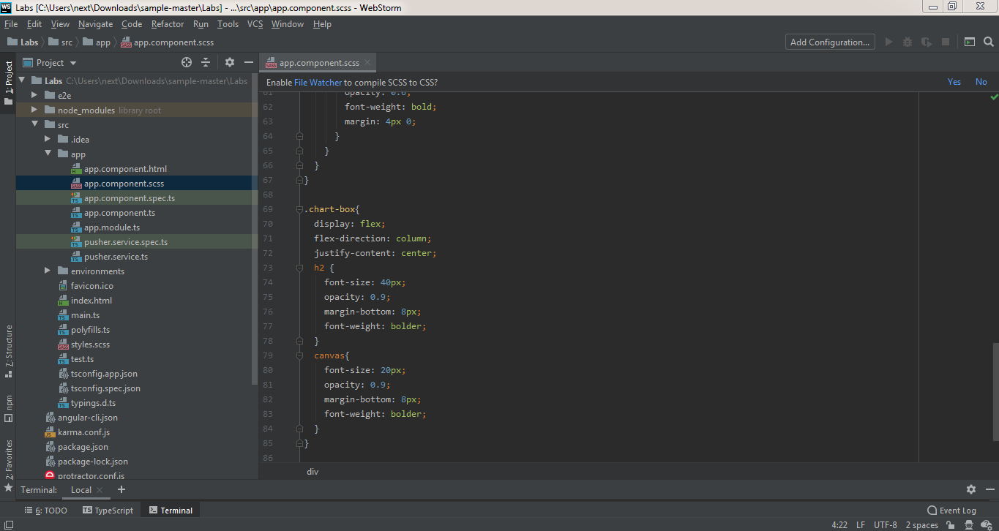

app.component.ts file

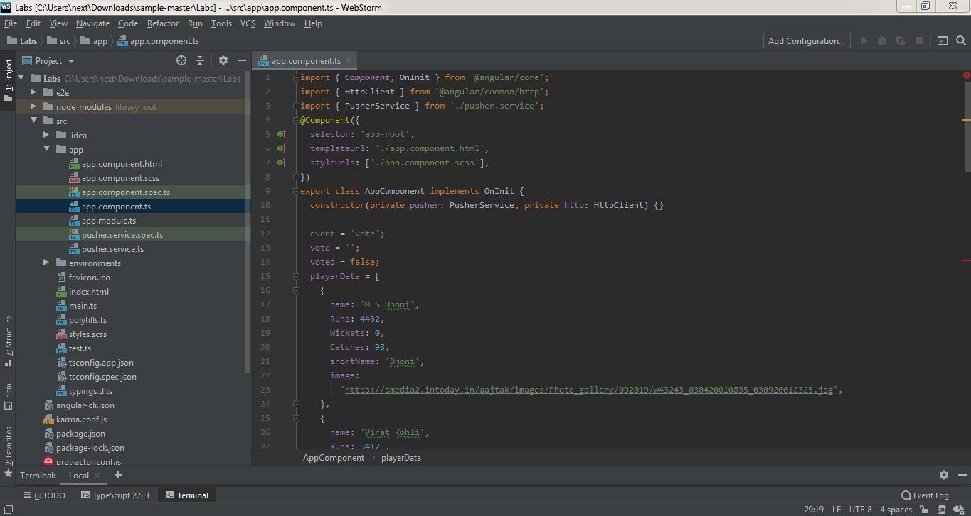

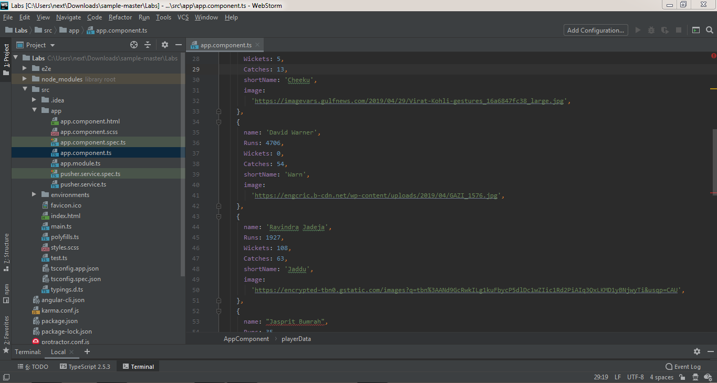

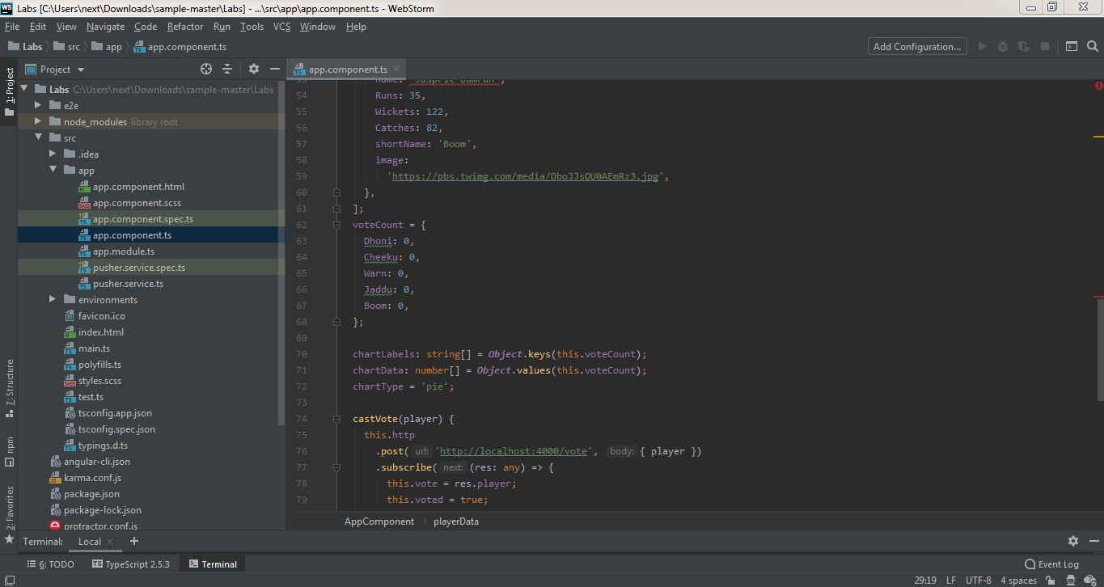

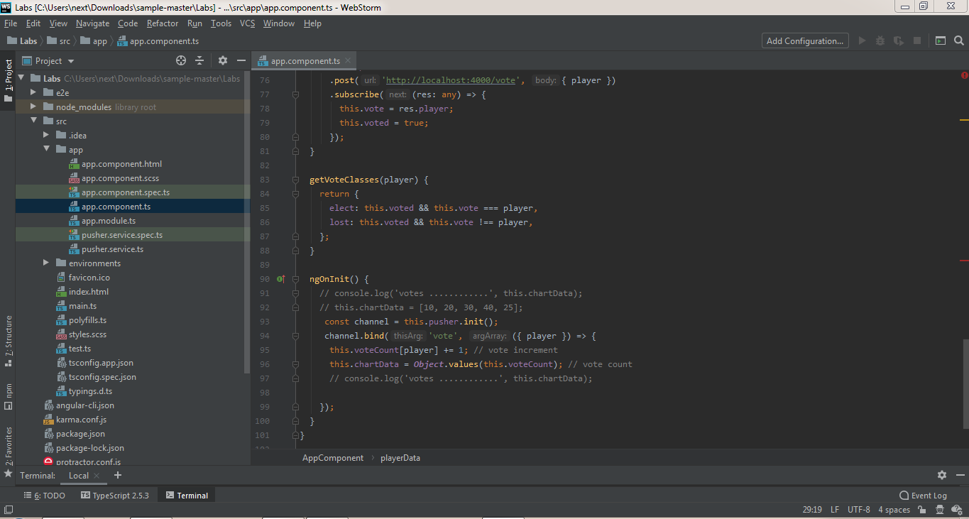

app.module.ts file

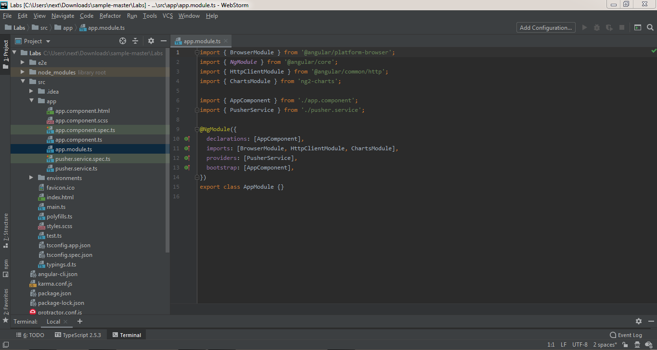

pusher.service.ts file

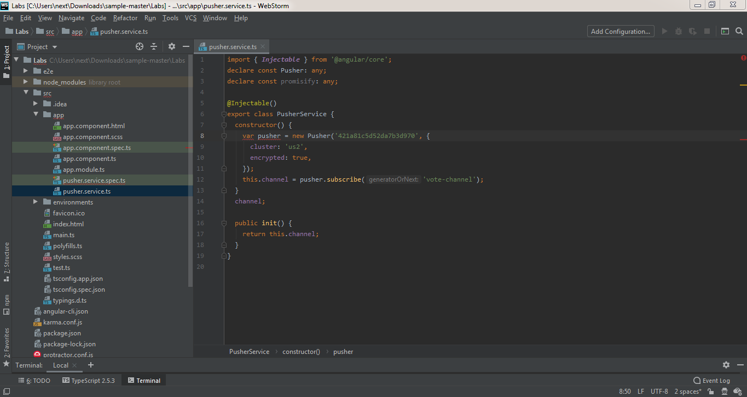

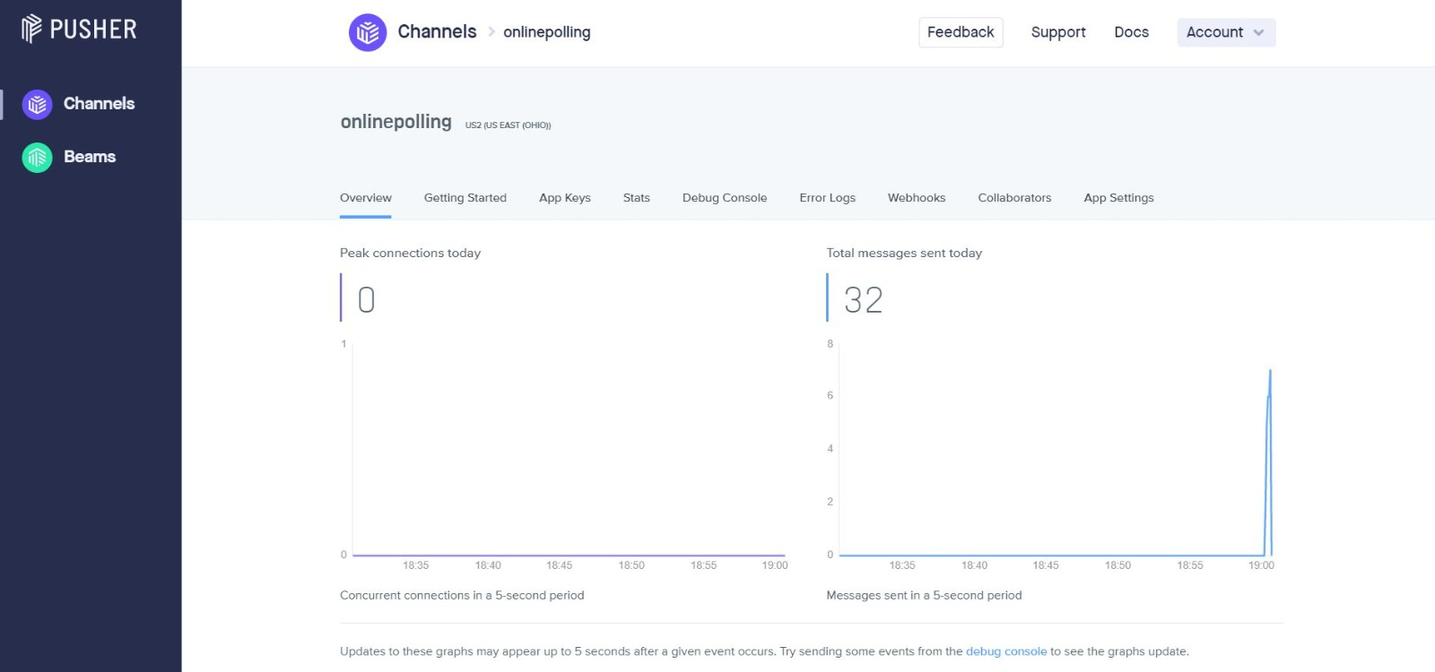

Pusher Service Dashboard

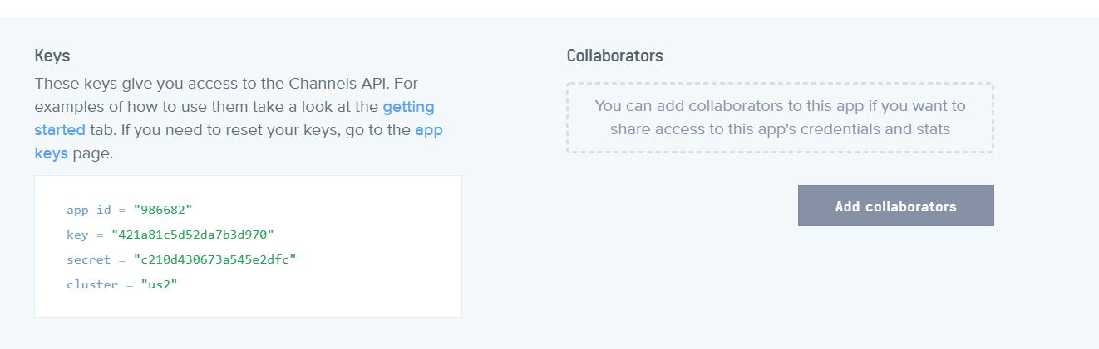

Pusher Service App ID, Key and Cluster Data

index.html file

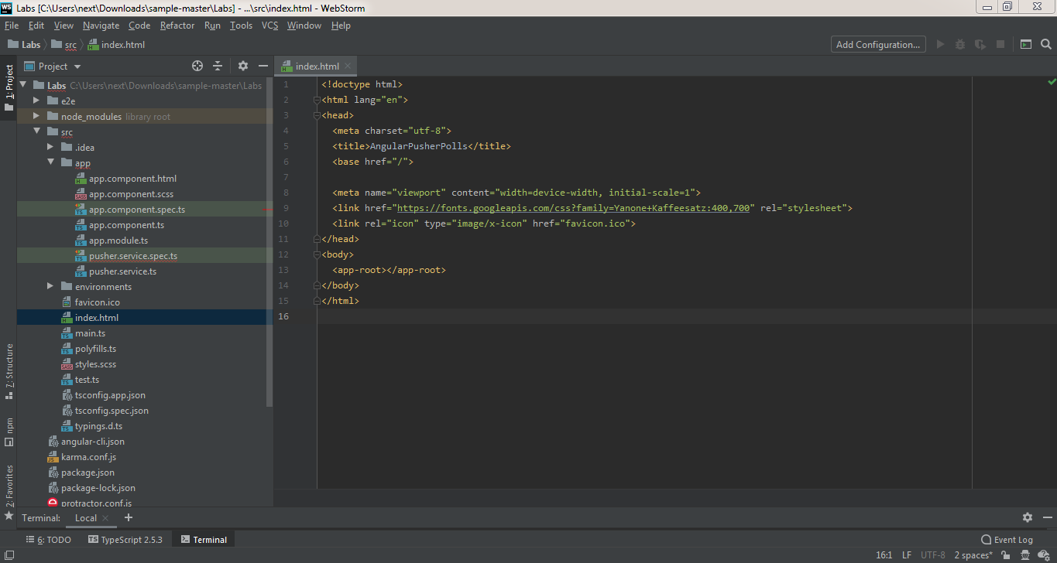

server.js file

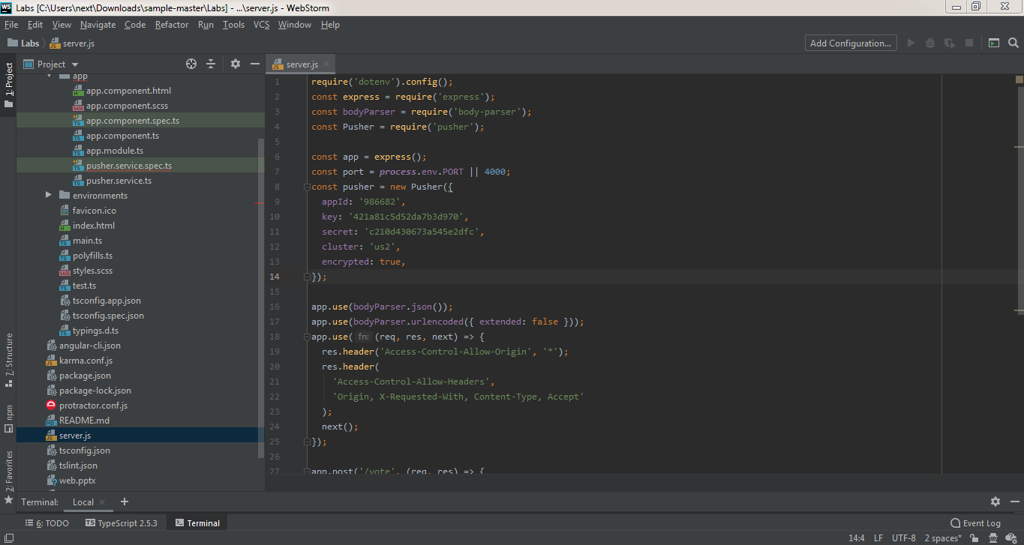

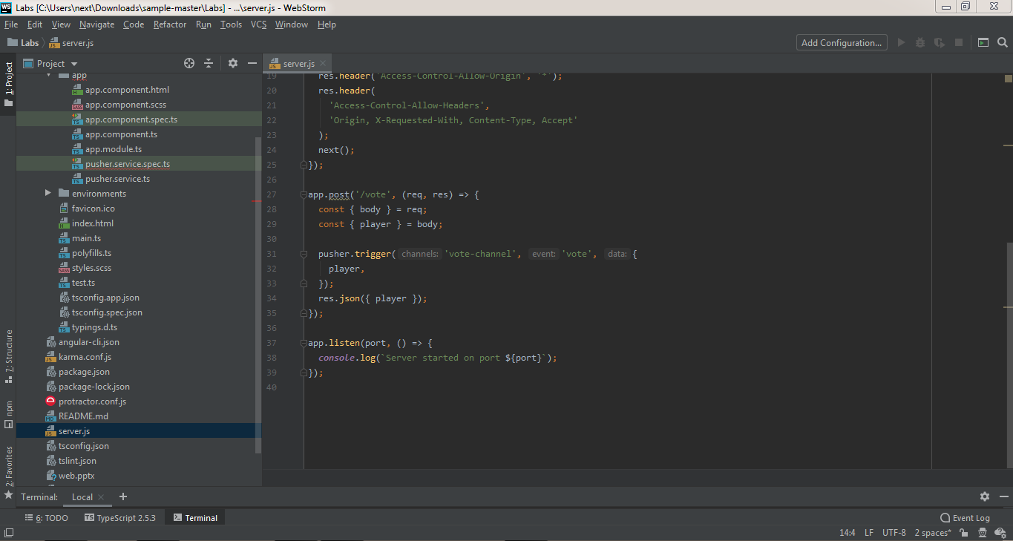

**Commands used in the project**

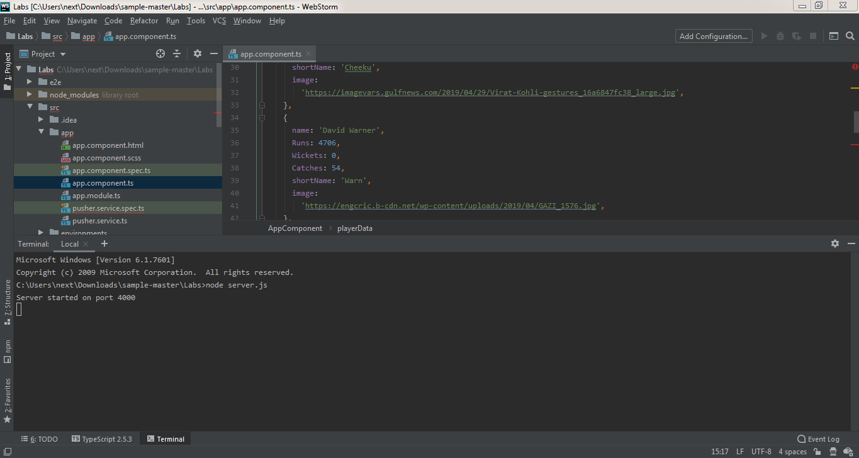

node server.js is used to build the server.

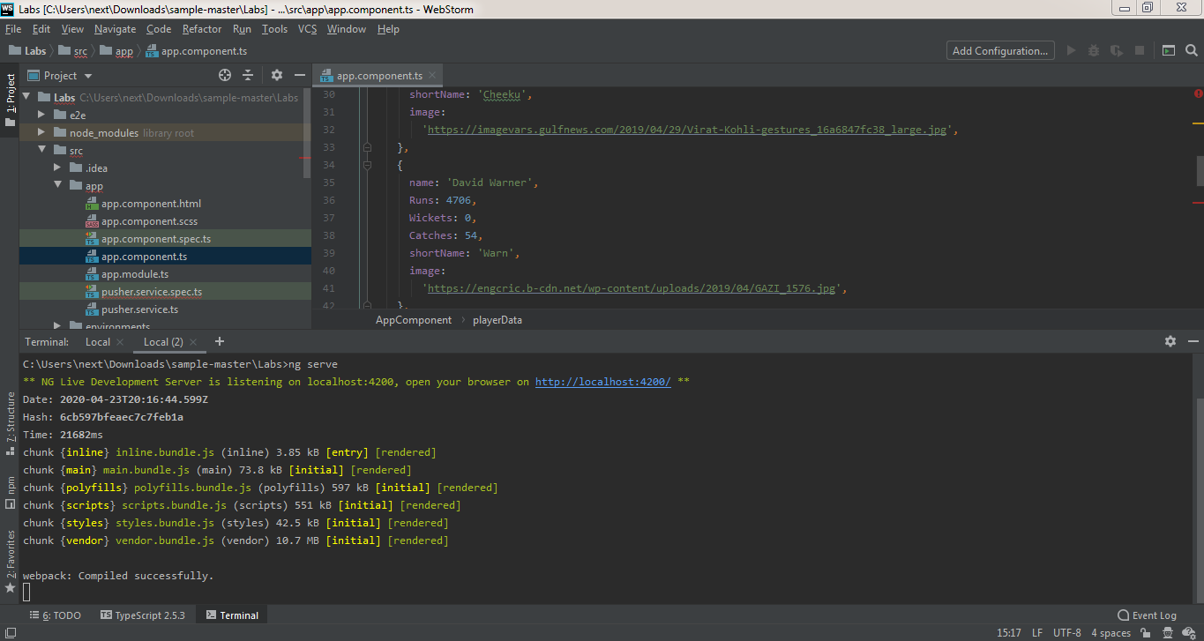

ng serve to build the angular application and serve it locally.

**Output Screenshots**

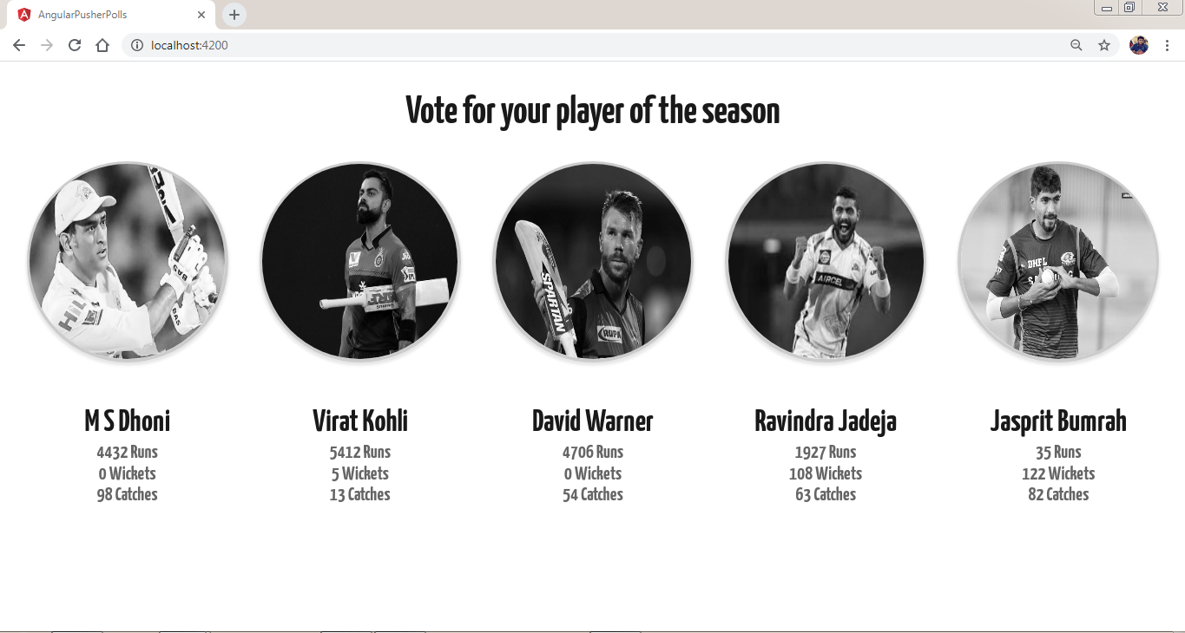

Displays all players which we provided in the code and a user can choose any one of them.

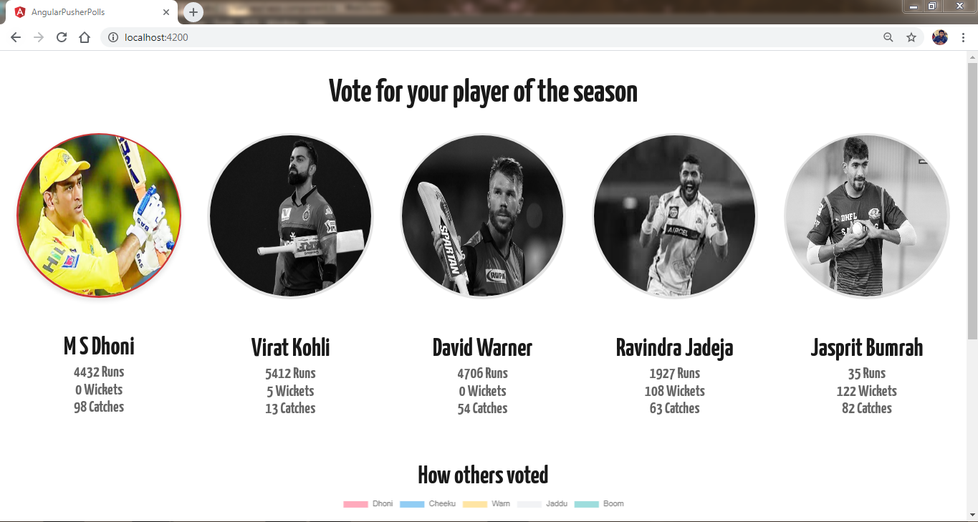

When a user clicks on a player, user can see how other have voted for their favorite players.

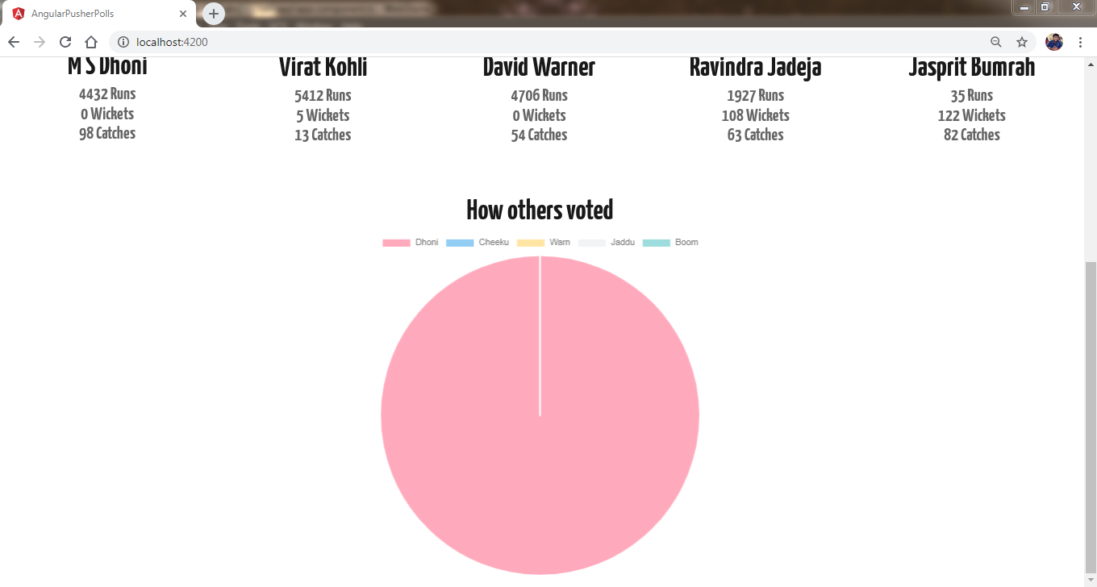

When user clicked on MS Dhoni and vote gets incremented and can be seen in the pie chart.

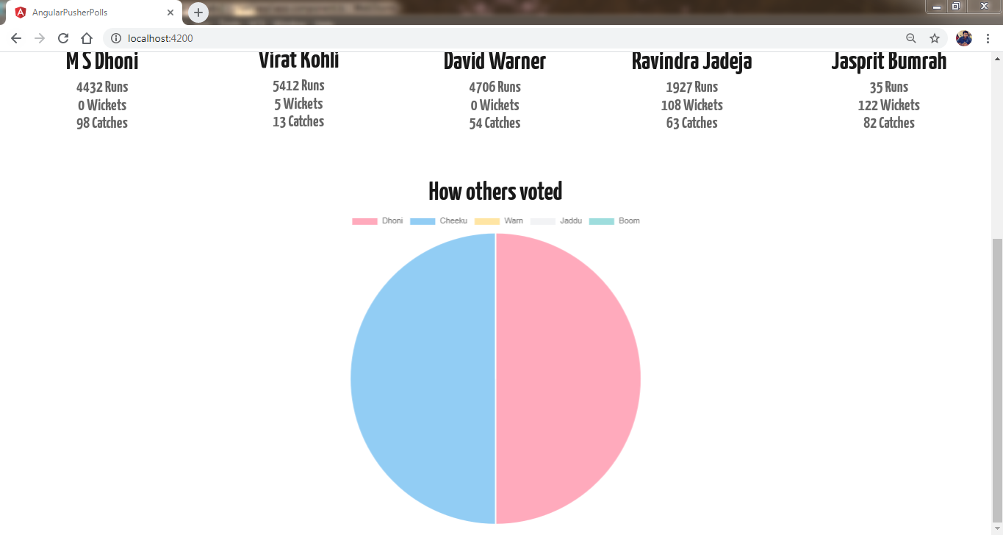

When other user votes for other player Virat Kohli and his vote count gets incremented by 1.

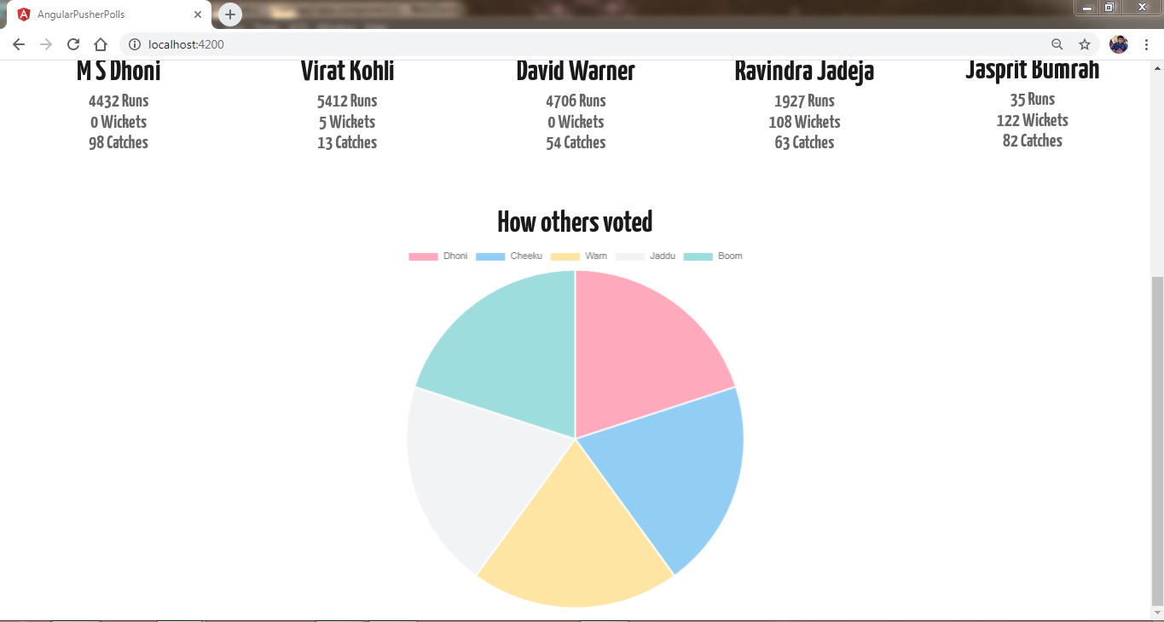

When each player in the application gets an equal vote share.

**Improvement from the Increment - 1**

In the increment 1 we have just build the application for displaying the data of the player where as in the increment 2 we have developed the code to display an pie chart of vote count of players on voting the favorite player of user and also used pusher service to add the data to the server.

**Work/Module Sharing among Teammates**

The work is being shared equally between all the teammates and each one has been provided with a specific task with a timeline.

**Issues and Blockages in the Project**

1. Web Socket Error while accessing the pusher service.
2. Single User has chance to duplicate the votes to their favorite player.
3. Invalid Key Error in pusher service.

**Future Advancements**

Adding an email id as a verification to prevent the duplication of votes by a user and also trying to host the web site during an Indian Premier League Season in Year 2021.

**References**

<https://pusher.com/tutorials/>

<https://www.npmjs.com/package/pusher>

<https://www.freecodecamp.org/news/how-to-create-an-online-poll-with-asp-net-core-angular-5-and-highcharts-85ff7fecbaf1/>

<https://www.twilio.com/blog/transfer-files-data-javascript-applications-angular-node-js>

<https://blog.couchbase.com/creating-front-end-user-profile-store-angular-typescript/>